St. John’s Episcopal Church
The Sixth Sunday of Easter
Morning Prayer Rite II May 14, 2023

Worship Leader: Becky Foster
Lector: Jack Dodd Music Director: Kitty Underwood

Opening Hymn For the Beauty of the Earth Hymn 416

Thanks be to God, who gives us the victory through our Lord Jesus Christ. 1 Corinthians 15:57

Confession of Sin
Let us confess our sins against God and our neighbor.
Silence may be kept.
Officiant and People together, all kneeling
Most merciful God, we confess that we have sinned against you in thought, word, and deed, by what we have done, and by what we have left undone. We have not loved you with our whole heart; we have not loved our neighbors as ourselves. We are truly sorry and we humbly repent. For the sake of your Son Jesus Christ,
have mercy on us and forgive us; that we may delight in your will, and walk in your ways, to the glory of your Name. Amen.

Almighty God have mercy on us, forgive us all our sins through our Lord Jesus Christ, strengthen us in all
goodness, and by the power of the Holy Spirit keep us in eternal life. Amen.

The Invitatory and Psalter

Officiant | Lord, open our lips.
People | And our mouth shall proclaim your praise.
Glory to the Father, and to the Son, and to the Holy Spirit: as it was in the beginning, is now, and will be for ever. Amen. Alleluia.
The Lord has shown forth his glory: Come let us adore him.
Venite (sung) Psalm 95:1-7 H S-35
Come, let us sing to the Lord; *
let us shout for joy to the Rock of our salvation.
Let us come before his presence with thanksgiving *
and raise a loud shout to him with psalms.
For the Lord is a great God, *
and a great King above all gods.
In his hand are the caverns of the earth, *
and the heights of the hills are his also.
The sea is his, for he made it, *
and his hands have molded the dry land.
Come, let us bow down, and bend the knee, *
and kneel before the Lord our Maker.
For he is our God,
and we are the people of his pasture and the sheep of his hand. *
Oh, that today you would hearken to his voice!

Psalm 66:7-18 Insert

At the end of the psalm is said:

Glory to the Father, and to the Son, and to the Holy Spirit: as it was in the beginning, is now, and will be for ever. Amen.

The Lessons

First Reading
Acts 17:22-31 Insert

Canticle: The first Song of Isaiah H 679

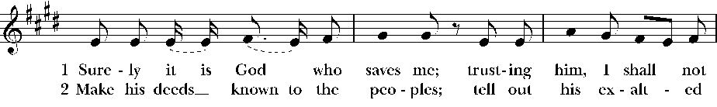
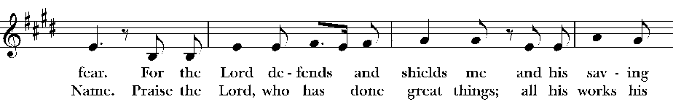
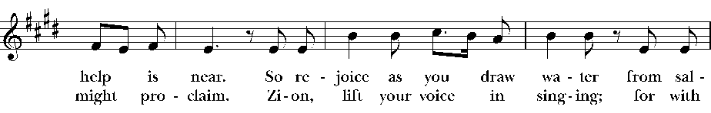
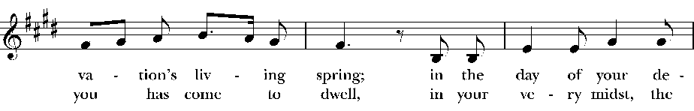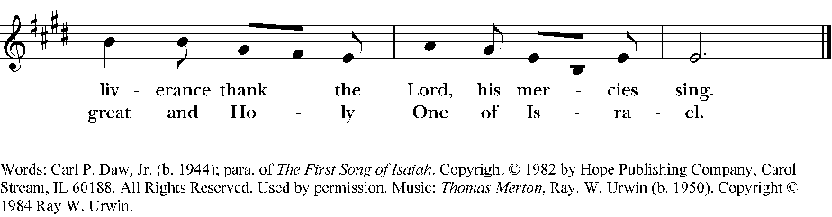

Second Reading
1 Peter 3:13-22
Insert

Canticle: Glorify thy Name Praise 27
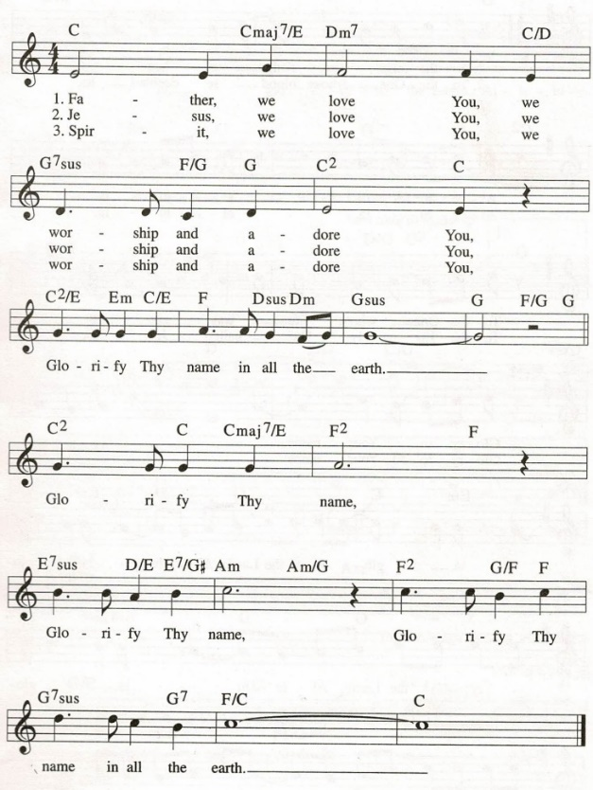

Third Lesson

John 14:15-21 Insert

Sermon: Becky Foster

The Apostles' Creed
Officiant and People together, all standing
I believe in God, the Father almighty,
creator of heaven and earth;
I believe in Jesus Christ, his only Son, our Lord.
He was conceived by the power of the Holy Spirit
and born of the Virgin Mary.
He suffered under Pontius Pilate,
was crucified, died, and was buried.
He descended to the dead.
On the third day he rose again.
He ascended into heaven,
and is seated at the right hand of the Father.
He will come again to judge the living and the dead.
I believe in the Holy Spirit,
the holy catholic Church,
the communion of saints,
the forgiveness of sins
the resurrection of the body,
and the life everlasting. Amen.
The Prayers
The People stand or kneel
Officiant | The Lord be with you.
People | And also with you.
Officiant | Let us pray.

Officiant and People
Our Father, who art in heaven,
hallowed be thy Name,
thy kingdom come,
thy will be done,
on earth as it is in heaven.
Give us this day our daily bread.
And forgive us our trespasses,
as we forgive those
who trespass against us.
And lead us not into temptation,
but deliver us from evil.
For thine is the kingdom,
and the power, and the glory,
for ever and ever. Amen.

Suffrages A
V. Show us your mercy, O Lord;
R. And grant us your salvation.
V. Clothe your ministers with righteousness;
R. Let your people sing with joy.
V. Give peace, O Lord, in all the world;
R. For only in you can we live in safety.
V. Lord, keep this nation under your care;
R. And guide us in the way of justice and truth.
V. Let your way be known upon earth;
R. Your saving health among all nations.
V. Let not the needy, O Lord, be forgotten;
R. Nor the hope of the poor be taken away.
V. Create in us clean hearts, O God;
R. And sustain us with your Holy Spirit.
Suffrages B
V. Save your people, Lord, and bless your inheritance;
R. Govern and uphold them, now and always.
V. Day by day we bless you;
R. We praise your name for ever.
V. Lord, keep us from all sin today;
R. Have mercy upon us, Lord, have mercy.
V. Lord, show us your love and mercy;
R. For we put our trust in you.
V. In you, Lord, is our hope;
R. And we shall never hope in vain.

The Collect of the Day:

O God, you have prepared for those who love you such good things as surpass our understanding: Pour into our hearts such love towards you, that we, loving you in all things and above all things, may obtain your promises, which exceed all that we can desire; through Jesus Christ our Lord, who lives and reigns with you and the Holy Spirit, one God, for ever and ever. Amen.

A Collect for Sundays

O God, you make us glad with the weekly remembrance of the glorious resurrection of your Son our Lord: Give us this day such blessing through our worship of you, that the week to come may be spent in your favor; through Jesus Christ our Lord. Amen.
A Collect for Peace
O God, the author of peace and lover of concord, to know you is eternal life and to serve you is perfect freedom: Defend us, your humble servants, in all assaults of our enemies; that we, surely trusting in your defense, may not fear the power of any adversaries; through the might of Jesus Christ our Lord.
Amen.
A Collect for Grace
Lord God, almighty and everlasting Father, you have
brought us in safety to this new day: Preserve us with your mighty power, that we may not fall into sin, nor be overcome by adversity; and in all we do, direct us to the fulfilling of your purpose; through Jesus Christ our Lord. Amen.
A Collect for Guidance
Heavenly Father, in you we live and move and have our
being: We humbly pray you so to guide and govern us by
your Holy Spirit, that in all the cares and occupations of our life we may not forget you, but may remember that we are ever walking in your sight; through Jesus Christ our Lord.
Amen.

A Collect for the Renewal of Life

O God, the King eternal, whose light divides the day from the night and turns the shadow of death into the morning: Drive far from us all wrong desires, incline our hearts to keep your law, and guide our feet into the way of peace; that, having done your will with cheerfulness during the day, we may, when night comes, rejoice to give you thanks; through Jesus Christ our Lord. Amen.

A Collect for Mission

O God, you have made of one blood all the peoples of the earth, and sent your blessed Son to preach peace to those who are far off and to those who are near: Grant that people everywhere may seek after you and find you; bring the nations into your fold; pour out your Spirit upon all flesh; and hasten the coming of your kingdom; through Jesus Christ our Lord. Amen.

Please see bulletin cover for prayer lists.

We pray for those listed on our Anglican and diocesan cycles of Prayer…

We pray for all who are sick and especially those on our prayer lists…

We pray for those who are unable to be in church…

We pray for those serving in the military…

We pray for the special needs and concerns of this congregation. The people may add their own petitions.

We thank you Lord, for all the blessings of this life. The people may add their own thanksgivings.

We pray for all who have died, that they may have a place in your eternal kingdom. The people may add their own petitons.

Hasten, O Father, the coming of thy kingdom; and grant that we thy servants, who now live by faith, may with joy behold thy Son at his coming in glorious majesty; even Jesus Christ, our only Mediator and Advocate. Amen
The Peace
 | The peace of the Lord be always with you.
People | And also with you.

Announcements, Birthdays, and Anniversaries
Prayers are found in the back of the Book of Common Prayer

The Offertory

Ascribe to the Lord the honor due his Name; bring
offering and come into his courts. Psalm 96:8

Offertory Hymn Be Thou My Vision Hymn 488

Doxology
Praise God, from whom all blessings flow;
Praise him, all creatures here below;
Praise him above, ye heavenly host;
Praise Father, Son, and Holy Ghost. Amen.

V. All things come of thee, O Lord.
R. And of thine own have we given thee. (1 Chr. 29:14)

The General Thanksgiving

Almighty God, Father of all mercies,
we your unworthy servants give you humble thanks
for all your goodness and loving-kindness
to us and to all whom you have made. We bless you for our creation, preservation, and all the blessings of this life; but above all for your immeasurable love in the redemption of the world by our Lord Jesus Christ; for the means of grace, and for the hope of glory. And, we pray, give us such an awareness of your mercies, that with truly thankful hearts we may show forth your praise, not only with our lips, but in our lives, by giving up our selves to your service, and by walking before you in holiness and righteousness all our days; through Jesus Christ our Lord, to whom, with you and the Holy Spirit, be honor and glory throughout all ages. Amen.

A Prayer of St. Chrysostom

Almighty God, you have given us grace at this time with one accord to make our common supplication to you; and you have promised through your well-beloved Son that when two or three are gathered together in his Name you will be in the midst of them: Fulfill now, O Lord, our desires and petitions as may be best for us; granting us in this world knowledge of your truth, and in the age to come life everlasting. Amen.

Let us bless the Lord.
Thanks be to God.

Closing Hymn Come We That Love the Lord Hymn 392

The grace of our Lord Jesus Christ, and the love of God, and the fellowship of the Holy Spirit, be with us all evermore. Amen. 2 Corinthians 13:14

Final Blessing Congregation
Amen
+++++++++++++++++++++++++++++++++++++++++++++++++++++

