The First Sunday in Lent
Morning Prayer Rite I February 26, 2023

Worship Leader: Becky Foster
Lector: Margaret Smith Music Director: Kitty Underwood

Opening Hymn Lord, who throughout these forty days Hymn 142
Jesus said, "Whosoever will come after me, let him deny
himself, and take up his cross, and follow me." Mark 8:34

Grace to you and peace from God our Father and from the Lord Jesus Christ. Philippians 1:2

Confession of Sin
Let us humbly confess our sins unto Almighty God.
Silence may be kept.
Officiant and People together, all kneeling
Almighty and most merciful Father,
we have erred and strayed from thy ways like lost
sheep,
we have followed too much the devices and desires of
our own hearts,
we have offended against thy holy laws,
we have left undone those things which we ought to
have done,
and we have done those things which we ought not to
have done.
But thou, O Lord, have mercy upon us,
spare thou those who confess their faults,
restore thou those who are penitent,
according to thy promises declared unto mankind
in Christ Jesus our Lord; and grant, O most merciful Father, for his sake, that we may hereafter live a godly, righteous, and sober life, to the glory of thy holy Name. Amen.

The Almighty and merciful Lord grant us absolution and remission of all our sins, true repentance, amendment of life, and the grace and consolation of his Holy Spirit. Amen.

The Invitatory and Psalter
All stand
Officiant | O Lord, open thou our lips.
People | And our mouth shall show forth thy praise.
Officiant and People
Glory to the Father, and to the Son, and to the Holy Spirit: as it was in the beginning, is now, and will be for ever. Amen.
The Lord is full of compassion and mercy: O come, let us adore him.

Venite (spoken) Psalm 95:1-7
O come, let us sing unto the Lord; *
let us heartily rejoice in the strength of our salvation.
Let us come before his presence with thanksgiving *
and show ourselves glad in him with psalms.
For the Lord is a great God, *
and a great King above all gods.
In his hand are all the corners of the earth, *
and the strength of the hills is his also.
The sea is his, and he made it, *
and his hands prepared the dry land.
O come, let us worship and fall down, *
and kneel before the Lord our Maker.
For he is the Lord our God, *
and we are the people of his pasture
and the sheep of his hand.
O worship the Lord in the beauty of holiness; *
let the whole earth stand in awe of him.
For he cometh, for he cometh to judge the earth, *
and with righteousness to judge the world
and the peoples with his truth.
Psalm: 32 Insert

At the end of the psalm is said:
Glory to the Father, and to the Son, and to the Holy Spirit: * as it was in the beginning, is now, and will be for ever. Amen.

The Lessons

First Lesson: Genesis 2:15-17; 3:1-7 Insert

Canticle: The first Song of Isaiah H 679
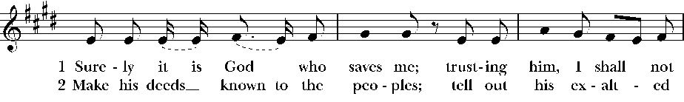
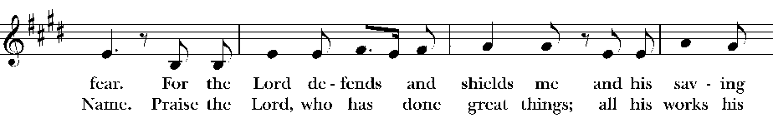
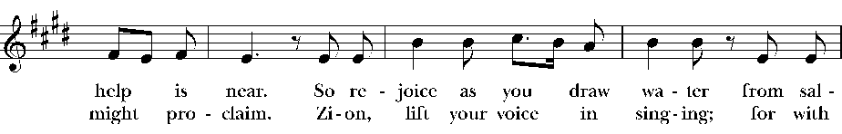
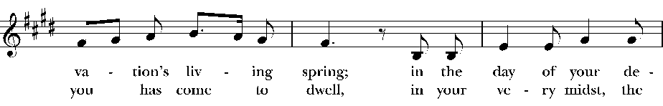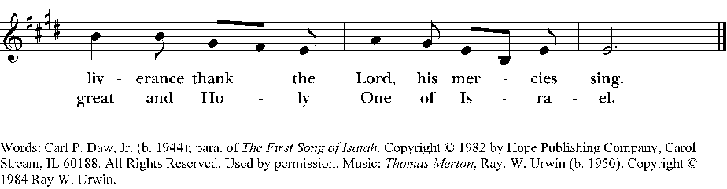

Second Lesson: Romans 5:12-19 Insert

Canticle (spoken): A song of Penitence #14

O Lord and Ruler of the hosts of heaven, *
God of Abraham, Isaac, and Jacob,
and of all their righteous offspring:
You made the heavens and the earth, *
with all their vast array.
All things quake with fear at your presence; *
they tremble because of your power.
But your merciful promise is beyond all measure; *
it surpasses all that our minds can fathom.
O Lord, you are full of compassion, *
long-suffering, and abounding in mercy.
You hold back your hand; *
you do not punish as we deserve.
In your great goodness, Lord,
you have promised forgiveness to sinners, *
that they may repent of their sin and be saved.
And now, O Lord, I bend the knee of my heart, *
and make my appeal, sure of your gracious goodness.
I have sinned, O Lord, I have sinned, *
and I know my wickedness only too well.
Therefore I make this prayer to you: *
Forgive me, Lord, forgive me.
Do not let me perish in my sin, *
nor condemn me to the depths of the earth.
For you, O Lord, are the God of those who repent, *
and in me you will show forth your goodness.
Unworthy as I am, you will save me,
in accordance with your great mercy, *
and I will praise you without ceasing all the days of my life.
For all the powers of heaven sing your praises, *
and yours is the glory to ages of ages. Amen.

Third Lesson: Matthew 4:1-11 Insert

Sermon: Becky Foster
The Apostles' Creed
Officiant and People together, all standing
I believe in God, the Father almighty,
maker of heaven and earth;
And in Jesus Christ his only Son our Lord;
who was conceived by the Holy Ghost,
born of the Virgin Mary,
suffered under Pontius Pilate,
was crucified, dead, and buried.
He descended into hell.
The third day he rose again from the dead.
He ascended into heaven,
and sitteth on the right hand of God the Father almighty.
From thence he shall come to judge the quick and the dead.
I believe in the Holy Ghost,
the holy catholic Church,
the communion of saints,
the forgiveness of sins,
the resurrection of the body,
and the life everlasting. Amen.

The Prayers
The People stand or kneel
Officiant | The Lord be with you.
People | And with thy spirit.
Officiant | Let us pray.
Officiant and People
Our Father, who art in heaven,
hallowed be thy Name,
thy kingdom come,
thy will be done,
on earth as it is in heaven.
Give us this day our daily bread.
And forgive us our trespasses,
as we forgive those
who trespass against us.
And lead us not into temptation,
but deliver us from evil.
For thine is the kingdom,
and the power, and the glory,
for ever and ever. Amen.

Suffrages A
V. O Lord, show thy mercy upon us;
R. And grant us thy salvation.
V. Endue thy ministers with righteousness;
R. And make thy chosen people joyful.
V. Give peace, O Lord, in all the world;
R. For only in thee can we live in safety.
V. Lord, keep this nation under thy care;
R. And guide us in the way of justice and truth.
V. Let thy way be known upon earth;
R. Thy saving health among all nations.
V. Let not the needy, O Lord, be forgotten;
R. Nor the hope of the poor be taken away.
V. Create in us clean hearts, O God;
R. And sustain us with thy Holy Spirit.
The Collect of the Day:
Almighty God, whose blessed Son was led by the Spirit to be tempted of Satan: Make speed to help thy servants who are assaulted by manifold temptations; and, as thou knowest their several infirmities, let each one find thee mighty to save; through Jesus Christ thy Son our Lord, who liveth and reigneth with thee and the Holy Spirit, one God, now and forever. Amen.

A Collect for Sundays
O God, who makest us glad with the weekly remembrance of the glorious resurrection of thy Son our Lord: Grant us this day such blessing through our worship of thee, that the days to come may be spent in thy favor; through the same Jesus Christ our Lord. Amen.

A Collect for the Renewal of Life
O God, the King eternal, who dividest the day from the
night and turnest the shadow of death into the morning:
Drive far from us all wrong desires, incline our hearts to keep thy law, and guide our feet into the way of peace; that, having done thy will with cheerfulness while it was day, we may, when the night cometh, rejoice to give thee thanks; through Jesus Christ our Lord. Amen.

A Collect for Mission
Lord Jesus Christ, who didst stretch out thine arms of love on the hard wood of the cross that everyone might come within the reach of thy saving embrace: So clothe us in thy Spirit that we, reaching forth our hands in love, may bringn those who do not know thee to the knowledge and love of thee; for the honor of thy Name. Amen.

Please see bulletin cover for prayer lists.

We pray for those listed on our Anglican and diocesan cycles of Prayer…

We pray for all who are sick and especially those on our prayer lists…

We pray for those who are unable to be in church…

We pray for those serving in the military…

We pray for the special needs and concerns of this congregation. The people may add their own petitions.

We thank you Lord, for all the blessings of this life. The people may add their own thanksgivings.

We pray for all who have died, that they may have a place in your eternal kingdom. The people may add their own petitons.

Lord Jesus Christ, you said to your apostles, "Peace I give to you; my own peace I leave with you:" Regard not our sins, but the faith of your Church, and give to us the peace and unity of that heavenly City, where with the Father and the Holy Spirit you live and reign, now and for ever. Amen.
The Peace
 | The peace of the Lord be always with you.
People | And with thy spirit.

Announcements, Birthdays, and Anniversaries
Prayers are found in the back of the Book of Common Prayer

The Offertory
Ascribe to the Lord the honor due his Name; bring
offering and come into his courts. Psalm 96:8

Offertory Anthem Just a Closer Walk with Thee LEVAS 72

Doxology
Praise God, from whom all blessings flow;
Praise him, all creatures here below;
Praise him above, ye heavenly host;
Praise Father, Son, and Holy Ghost. Amen.

V. All things come of thee, O Lord.
R. And of thine own have we given thee. (1 Chr. 29:14)

The General Thanksgiving

Almighty God, Father of all mercies,
we thine unworthy servants do give thee most humble and hearty thanks for all thy goodness and loving-kindness to us and to all men.
We bless thee for our creation, preservation,
and all the blessings of this life; but above all for thine inestimable love in the redemption of the world by our Lord Jesus Christ; for the means of grace, and for the hope of glory. And, we beseech thee, give us that due sense of all thy mercies, that our hearts may be unfeignedly thankful; and that we show forth thy praise, not only with our lips, but in our lives,
by giving up our selves to thy service, and by walking before thee in holiness and righteousness all our days;
through Jesus Christ our Lord, to whom, with thee and the Holy Ghost, be all honor and glory, world without end. Amen.

A Prayer of St. Chrysostom

Almighty God, who hast given us grace at this time with one accord to make our common supplication unto thee; and hast promised through thy well-beloved Son that when two or three are gathered together in his Name thou wilt be in the midst of them: Fulfill now, O Lord, the desires and petitions of thy servants as may be best for us; granting us in this world knowledge of thy truth, and in the world to come life everlasting. Amen.

Let us bless the Lord.
Thanks be to God.

The grace of our Lord Jesus Christ, and the love of God, and the fellowship of the Holy Spirit, be with us all evermore. Amen. 2 Corinthians 13:14

Closing Hymn: O love, how deep, how broad Hymn 448
+++++++++++++++++++++++++++++++++++++++++++++++++++++
Liturgical note – Today is the first Sunday in the season of Lent. Early Christians observed “a season of penitence and fasting” in preparation for the Paschal feast, or Pascha. The season now known as Lent (from an Old English word meaning “spring,” the time of lengthening days) has a long history. Originally, in places where Pascha was celebrated on a Sunday, the Paschal feast followed a fast of up to two days. In the third century this fast was lengthened to six days. Eventually this fast became attached to, or overlapped, another fast of forty days, in imitation of Christ's fasting in the wilderness. The forty-day fast was especially important for converts to the faith who were preparing for baptism, and for those guilty of notorious sins who were being restored to the Christian assembly. In the western church the forty days of Lent extend from Ash Wednesday through Holy Saturday, omitting Sundays. The last three days of Lent are the sacred Triduum of Maundy Thursday, Good Friday, and Holy Saturday. Today Lent has reacquired its significance as the final preparation of adult candidates for baptism.

The First Sunday in Lent, Year A

Genesis 2:15-17; 3:1-7
The Lord God took the man and put him in the garden of Eden to till it and keep it. And the Lord God commanded the man, “You may freely eat of every tree of the garden; but of the tree of the knowledge of good and evil you shall not eat, for in the day that you eat of it you shall die.”
Now the serpent was more crafty than any other wild animal that the Lord God had made. He said to the woman, “Did God say, ‘You shall not eat from any tree in the garden’?” The woman said to the serpent, “We may eat of the fruit of the trees in the garden; but God said, ‘You shall not eat of the fruit of the tree that is in the middle of the garden, nor shall you touch it, or you shall die.’“ But the serpent said to the woman, “You will not die; for God knows that when you eat of it your eyes will be opened, and you will be like God, knowing good and evil.” So when the woman saw that the tree was good for food, and that it was a delight to the eyes, and that the tree was to be desired to make one wise, she took of its fruit and ate; and she also gave some to her husband, who was with her, and he ate. Then the eyes of both were opened, and they knew that they were naked; and they sewed fig leaves together and made loincloths for themselves.

Psalm 32
1 Happy are they whose transgressions are forgiven, *
and whose sin is put away!
2 Happy are they to whom the Lord imputes no guilt, *
and in whose spirit there is no guile!
3 While I held my tongue, my bones withered away, *
because of my groaning all day long.
4 For your hand was heavy upon me day and night; *
my moisture was dried up as in the heat of summer.
5 Then I acknowledged my sin to you, *
and did not conceal my guilt.
6 I said," I will confess my transgressions to the Lord." *
Then you forgave me the guilt of my sin.
7 Therefore all the faithful will make their prayers to you in time of trouble; *
when the great waters overflow, they shall not reach them.
8 You are my hiding-place;
you preserve me from trouble; *
you surround me with shouts of deliverance.
9 "I will instruct you and teach you in the way that you should go; *
I will guide you with my eye.
10 Do not be like horse or mule, which have no understanding; *
who must be fitted with bit and bridle,
or else they will not stay near you."
11 Great are the tribulations of the wicked; *
but mercy embraces those who trust in the Lord.
12 Be glad, you righteous, and rejoice in the Lord; *
shout for joy, all who are true of heart.

Romans 5:12-19
As sin came into the world through one man, and death came through sin, and so death spread to all because all have sinned-- sin was indeed in the world before the law, but sin is not reckoned when there is no law. Yet death exercised dominion from Adam to Moses, even over those whose sins were not like the transgression of Adam, who is a type of the one who was to come.
But the free gift is not like the trespass. For if the many died through the one man's trespass, much more surely have the grace of God and the free gift in the grace of the one man, Jesus Christ, abounded for the many. And the free gift is not like the effect of the one man's sin. For the judgment following one trespass brought condemnation, but the free gift following many trespasses brings justification. If, because of the one man's trespass, death exercised dominion through that one, much more surely will those who receive the abundance of grace and the free gift of righteousness exercise dominion in life through the one man, Jesus Christ.

Therefore just as one man's trespass led to condemnation for all, so one man's act of righteousness leads to justification and life for all. For just as by the one man's disobedience the many were made sinners, so by the one man's obedience the many will be made righteous.

Matthew 4:1-11
Jesus was led up by the Spirit into the wilderness to be tempted by the devil. He fasted forty days and forty nights, and afterwards he was famished. The tempter came and said to him, “If you are the Son of God, command these stones to become loaves of bread.” But he answered, “It is written,
‘One does not live by bread alone,
but by every word that comes from the mouth of God.’”
Then the devil took him to the holy city and placed him on the pinnacle of the temple, saying to him, “If you are the Son of God, throw yourself down; for it is written,
‘He will command his angels concerning you,’
and ‘On their hands they will bear you up,
so that you will not dash your foot against a stone.’”
Jesus said to him, “Again it is written, ‘Do not put the Lord your God to the test.’”
Again, the devil took him to a very high mountain and showed him all the kingdoms of the world and their splendor; and he said to him, “All these I will give you, if you will fall down and worship me.” Jesus said to him, “Away with you, Satan! for it is written,
‘Worship the Lord your God,
and serve only him.’”
Then the devil left him, and suddenly angels came and waited on him.

