Maundy Thursday

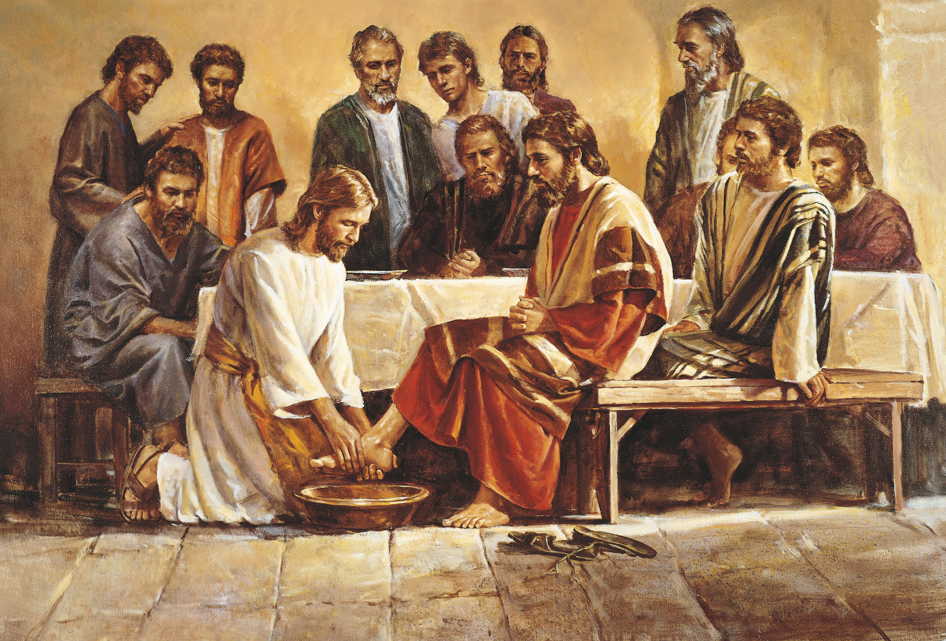

St. John’s Episcopal Church
Dryden, MI

March 28, 2024
Maundy Thursday
Rite I
Celebrant: Rev. Harold Schneider Lector: Wes Wagester
Preacher: Beckett Leclaire

Opening Hymn: L- 37
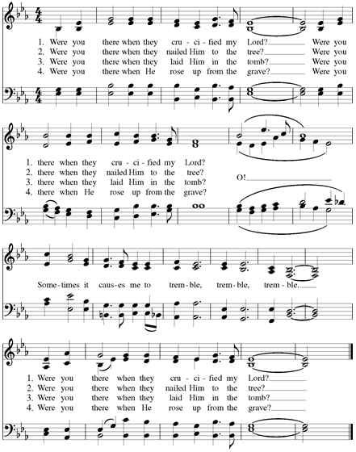
BCP#323
Blessed be God: Father, Son, and Holy Spirit.
And blessed be his kingdom, now and for ever. Amen.

Let us humbly confess our sins unto Almighty God.

Silence

Kyrie: S-91
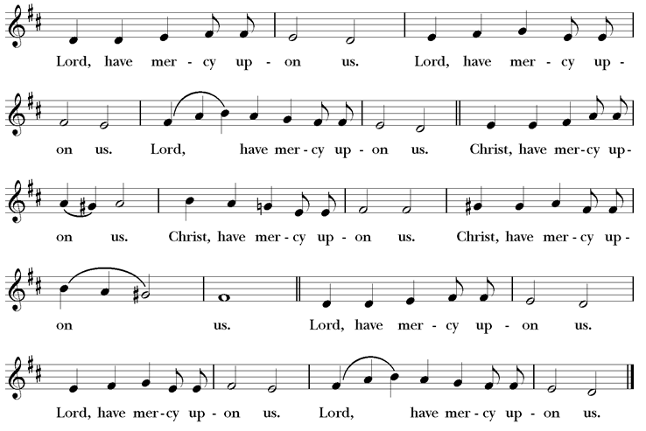

The Collect of the Day

 | The Lord be with you.
People | And with thy spirit.
Celebrant | Let us pray.

BCP #274
Almighty Father, whose dear Son, on the night before he suffered, instituted the Sacrament of his Body and Blood: Mercifully grant that we may receive it thankfully in remembrance of Jesus Christ our Lord, who in these holy mysteries gives us a pledge of eternal life; and who now lives and reigns with you and the Holy Spirit, one God, for ever and ever. Amen.

1st Reading: Exodus 12:1-4, [5-10], 11-14 Insert

Psalm 116:1, 10-17 Insert

2nd Reading: 1 Corinthians 11:23-26 Insert

Sequence Hymn: H 602
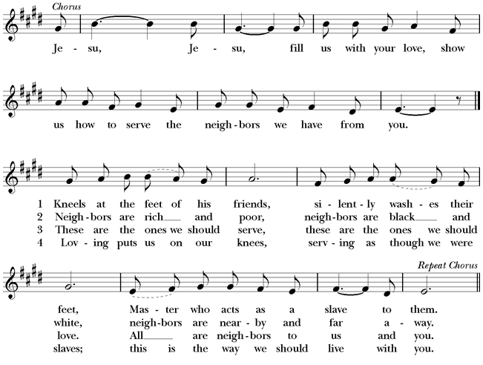

The Holy Gospel John 13:1-17, 31b-35 Insert

Homily Beckett Leclaire

BCP #274
The Ceremony of the Washing of Feet
The Lord Jesus, after he had supped with his disciples and had washed their feet, said to them, "Do you know what I, your Lord and Master, have done to you? I have given you an example, that you should do as I have done."
Peace is my last gift to you, my own peace I now leave with you; peace which the world cannot give, I give to you.
I give you a new commandment: Love one another as I have loved you.
Peace is my last gift to you, my own peace I now leave with you; peace which the world cannot give, I give to you.
By this shall the world know that you are my disciples: That you have love for one another.
The People come forward to have their feet washed.

BCP #328
The Prayers of the People

Let us pray for the whole state of Christ's Church and the world.
After each paragraph of this prayer, the People may make an appropriate response, as directed.
Almighty and everliving God, who in thy holy Word hast taught us to make prayers, and supplications, and to give thanks for all men: Receive these our prayers which we offer unto thy divine Majesty, beseeching thee to inspire continually the Universal Church with the spirit of truth, unity, and concord; and grant that all those who do confess thy holy Name may agree in the truth of thy holy Word, and
live in unity and godly love.
Give grace, O heavenly Father, to all bishops and other ministers, that they may, both by their life and doctrine, set forth thy true and lively Word, and rightly and duly administer thy holy Sacraments.
And to all thy people give thy heavenly grace, and especially to this congregation here present; that, with meek heart and due reverence, they may hear and receive thy holy Word, truly serving thee in holiness and righteousness all the days of their life.
We beseech thee also so to rule the hearts of those who bear the authority of government in this and every land that they may be led to wise decisions and right actions for the welfare and peace of the world.
Open, O Lord, the eyes of all people to behold thy gracious hand in all thy works, that, rejoicing in thy whole creation, they may honor thee with their substance, and be faithful stewards of thy bounty.
And we most humbly beseech thee, of thy goodness, O Lord, to comfort and succor all those who in his transitory life, are in trouble, sorrow, need, sickness, or any other adversity.
Additional petitions and thanksgivings may be included here.
And we also bless thy holy Name for all thy servants
departed this life in thy faith and fear, beseeching thee to grant them continual growth in thy love and service; and to grant us grace so to follow the good examples of all thy saints, that with them we may be partakers of thy heavenly kingdom.
Grant these our prayers, O Father, for Jesus Christ's sake,
our only Mediator and Advocate. Amen.
Let us Pray;
BCP # 331
Almighty God, Father of all mercies, we thine unworthy servants do give thee most humble and hearty thanks for all thy goodness and loving-kindness to us and to all men. We bless thee for our creation, preservation, and all the blessings of this life; but above all for thine inestimable love in the redemption of the world by our Lord Jesus Christ; for the means of grace, and for the hope of glory. And, we beseech thee, give us that due sense of all thy mercies, that our hearts may be unfeignedly thankful; and that we show forth thy praise, not only with our lips, but in our lives, by giving up our selves to thy service, and by walking before thee in holiness and righteousness all our days; through Jesus Christ our Lord, to whom, with thee and the Holy Ghost, be all honor and glory, world without end. Amen.
Let us bless the Lord.
Thanks be to God.
BCP#332
The Peace
All stand. The Celebrant says to the people;
The peace of the Lord be always with you
People: And with thy spirit

Announcements and Prayers
Offertory Anthem: The Upper Room Choir
Doxology: (verse 3 Hymn 380)
Praise God, from whom all blessings flow;
Praise him, all creatures here below;
Praise him above, ye heavenly host;
Praise Father, Son, and Holy Ghost. Amen

BCP #333
The Great Thanksgiving
The people remain standing. The Celebrant, whether bishop or priest, faces them and sings or says:

 | The Lord be with you.
People | And with thy spirit.
Celebrant | Lift up your hearts.
People | We lift them up unto the Lord.
Celebrant | Let us give thanks unto our Lord God.
People | It is meet and right so to do.
Then, facing the Holy Table, the Celebrant proceeds
It is very meet, right, and our bounden duty, that we should
at all times, and in all places, give thanks unto thee, O Lord,
holy Father, almighty, everlasting God.
Here a Proper Preface is sung or said on all Sundays.
Through Jesus Christ our Lord, who for our sins was lifted high upon the cross, that he might draw the whole world to himself, who by his suffering and death became the author of eternal salvation for all who put their trust in him.
Therefore, with Angels and Archangels, and with all the
company of heaven, we laud and magnify thy glorious Name; evermore praising thee, and saying,
Celebrant and People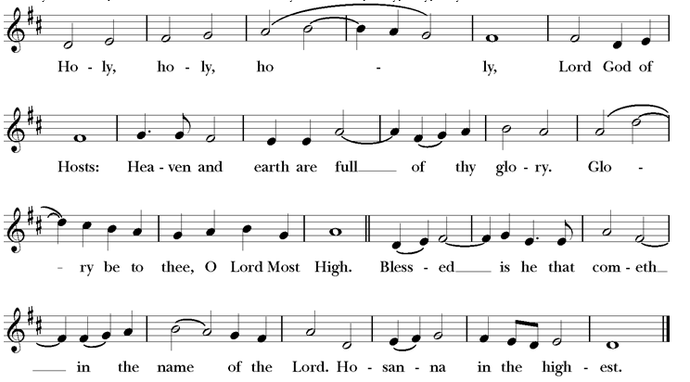
The people kneel or stand. Then the Celebrant continues
All glory be to thee, Almighty God, our heavenly Father, for
that thou, of thy tender mercy, didst give thine only Son Jesus Christ to suffer death upon the cross for our redemption; who made there, by his one oblation of himself once offered, a full, perfect, and sufficient sacrifice, oblation, and satisfaction, for the sins of the whole world; and did institute, and in his holy Gospel command us to continue, a perpetual memory of that his precious death and sacrifice, until his coming again.
For in the night in which he was betrayed, he took bread; and when he had given thanks, he brake it, and gave it to his disciples, saying, "Take, eat, this is my Body, which is given
for you. Do this in remembrance of me."
Likewise, after supper, he took the cup; and when he had
given thanks, he gave it to them, saying, "Drink ye all of this;
for this is my Blood of the New Testament, which is shed for
you, and for many, for the remission of sins. Do this, as oft as ye shall drink it, in remembrance of me."
Wherefore, O Lord and heavenly Father, according to the
institution of thy dearly beloved Son our Savior Jesus Christ,
we, thy humble servants, do celebrate and make here before
thy divine Majesty, with these thy holy gifts, which we now
offer unto thee, the memorial thy Son hath commanded us to make; having in remembrance his blessed passion and precious death, his mighty resurrection and glorious ascension; rendering unto thee most hearty thanks for the innumerable benefits procured unto us by the same.
And we most humbly beseech thee, O merciful Father, to
hear us; and, of thy almighty goodness, vouchsafe to bless
and sanctify, with thy Word and Holy Spirit, these thy gifts
and creatures of bread and wine; that we, receiving them
according to thy Son our Savior Jesus Christ's holy institution, in remembrance of his death and passion, may be partakers of his most blessed Body and Blood.
And we earnestly desire thy fatherly goodness mercifully to
accept this our sacrifice of praise and thanksgiving; most
humbly beseeching thee to grant that, by the merits and
death of thy Son Jesus Christ, and through faith in his blood,
we, and all thy whole Church, may obtain remission of our
sins, and all other benefits of his passion.
And here we offer and present unto thee, O Lord, our selves,
our souls and bodies, to be a reasonable, holy, and living
sacrifice unto thee; humbly beseeching thee that we, and all
others who shall be partakers of this Holy Communion, may
worthily receive the most precious Body and Blood of thy Son Jesus Christ, be filled with thy grace and heavenly benediction, and made one body with him, that he may dwell in us, and we in him.
And although we are unworthy, through our manifold sins,
to offer unto thee any sacrifice, yet we beseech thee to accept
this our bounden duty and service, not weighing our merits,
but pardoning our offenses, through Jesus Christ our Lord;
By whom, and with whom, in the unity of the Holy Ghost,
all honor and glory be unto thee, O Father Almighty, world
without end. AMEN.
BCP#336
And now, as our Savior Christ hath taught us, we are bold
to say,
Our Father, who art in heaven,
hallowed be thy Name,
thy kingdom come,
thy will be done,
on earth as it is in heaven.
Give us this day our daily bread.
And forgive us our trespasses,
as we forgive those who trespass against us.
And lead us not into temptation,
but deliver us from evil.
For thine is the kingdom, and the power, and the glory,
for ever and ever. Amen.
BCP #337
The Breaking of the Bread

The Celebrant breaks the consecrated Bread. Silence is kept.

Christ our Passover is sacrificed for us;
Therefore let us keep the feast.

Angus Dei (sung)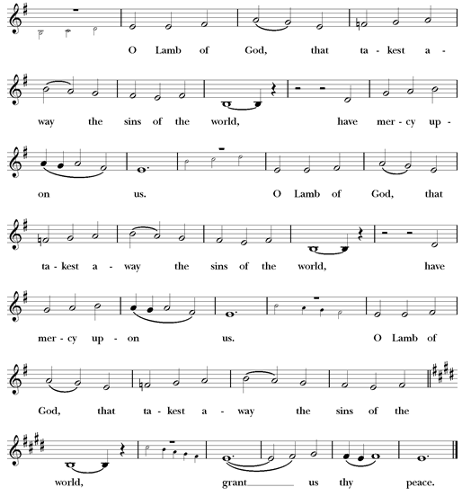

We do not presume to come to this thy Table, O merciful Lord, trusting in our own righteousness, but in thy manifold and great mercies. We are not worthy so much as to gather up the crumbs under thy Table. But thou art the same Lord whose property is always to have mercy. Grant us therefore, gracious Lord, so to eat the flesh of thy dear Son Jesus Christ, and to drink his blood, that we may evermore dwell in him, and he in us. Amen.

The Gifts of God for the People of God. Take them in remembrance that Christ died for you, and feed on him in your hearts by faith, with thanksgiving.

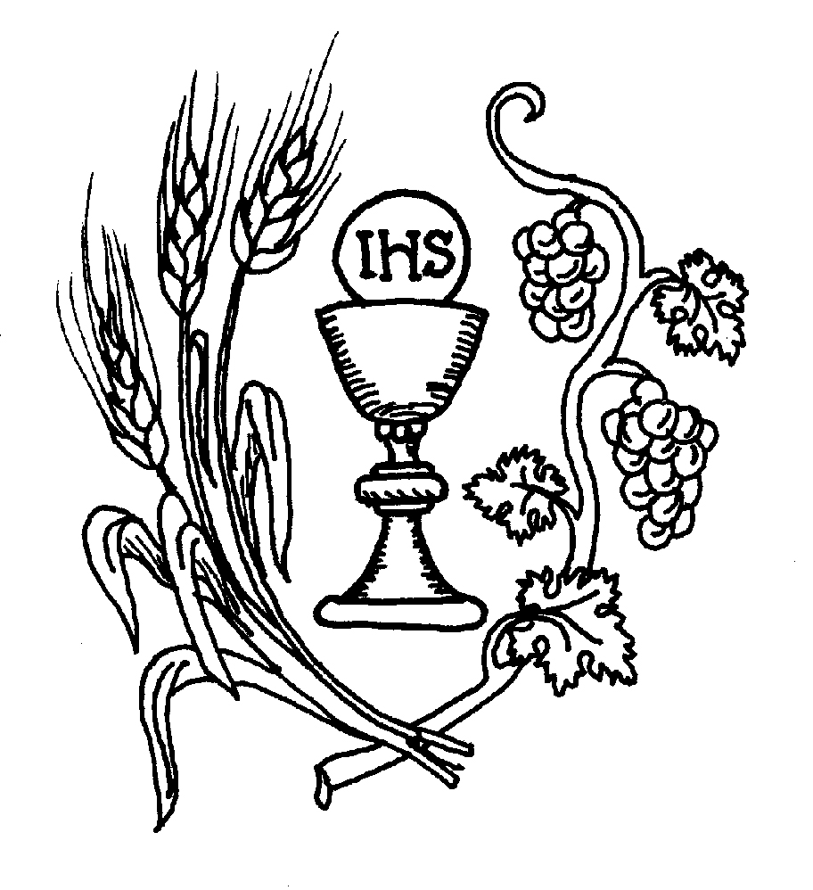
Ministration of Communion – All are welcome at God’s table.

Communion Anthem: In Remembrance of Me L-149

Post Communion Prayer

Let us pray.

BCP #339
Almighty and everliving God, we most heartily thank thee
for that thou dost feed us, in these holy mysteries, with the spiritual food of the most precious Body and Blood of thy Son our Savior Jesus Christ; and dost assure us thereby of thy favor and goodness towards us; and that we are very members incorporate in the mystical body of thy Son, the blessed company of all faithful people; and are also heirs, through hope, of thy everlasting kingdom. And we humbly beseech thee, O heavenly Father, so to assist us with thy grace, that we may continue in that holy fellowship, and do all such good works as thou hast prepared for us to walk in; through Jesus Christ our Lord, to whom with thee and the Holy Ghost, be all honor and glory, world without end.
Amen.

The Blessing
Let Us bless the Lord
Thanks be to God.

The Stripping of the Altar
This will take place in silence for those helping to remove items from the Sanctuary to the Sacristy. Please remain seated in silence until the altar area is completely stripped. Following the Stripping, please depart in continued silence.

++++++++++++++++++++++++++++++++++++++++

